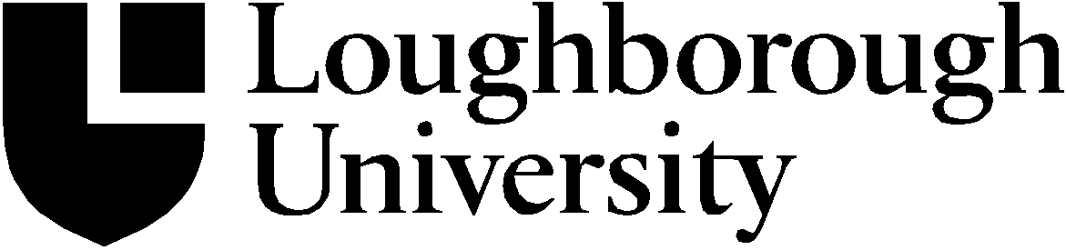

The Council

COUN12-M6
Minutes of the (Special) meeting of the University Council held on Friday, 12 October 2012.
Members:
Sir Peter Bonfield (Chair); Professor Bob Allison; John Blackwell; Penny Coates (ab); Lord Sebastian Coe; Dr Sophie Crouchman; Brian Dent; Gifty Edila (ab); Christine Fisher; Sir John Gains; Professor Jacqui Glass (ab); Ann Greenwood; Professor Elaine Hobby; Alan Hughes; Professor Allan Jones; Professor Chris Linton; Jim Murphy; Professor Ric Parker (ab); Professor Helen Rendell (ab); Dr Carol Robinson; Sir Nigel Rudd (ab); Mark Sismey-Durrant; Dr Adrian Spencer; Dr Gerry Swallowe; Jane Tabor; Jon Walker.
In attendance:
Professor Morag Bell; Professor Mike Caine (for item 12/69-71); Dr Mark Hollingsworth; Professor Myra Nimmo; Dr Jennifer Nutkins; Professor Steve Rothberg; Andy Stephens; Miranda Routledge; Caroline Walker.
Apologies for absence were received from:
Gifty Edila; Professor Jacqui Glass; Professor Ric Parker; Professor Helen Rendell.

12/87 Minutes
Minutes of the (Special) Meeting of the Council held on 12 July 2012 (COUN12-M4) were CONFIRMED.

12/88 Operations Committee
Council RECEIVED a report from the Meetings held on 4 July and 10 September 2012.
COUN12-P119
12/89 Date of Next Meeting

Friday, 16 November 2012

Author – Mark Hollingsworth
Date – October 2012
Copyright (c) Loughborough University. All rights reserved.

